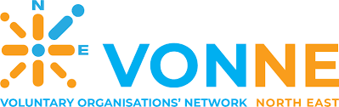


Pawel (name changed) is a 39-year-old man originally from Poland, currently living in the UK who has recently experienced significant health, financial, and housing difficulties. His situation demonstrates how physical injury, debt, and community safety issues can combine to create complex vulnerability.
Pawel suffered a left shoulder joint separation, which has limited his physical capacity and ability to work. A UC50 form was completed to assess his work capability, and he was assessed as having Limited Capability for Work (LCW). His restricted mobility has reduced his employment options, increasing financial strain and dependence on benefits.
Due to mounting debts, Pawel applied to StepChange Debt Charity for support. A Debt Management Plan (DMP) was successfully arranged with ICOS support, helping him consolidate and manage repayments in a structured and affordable way. This intervention reduced immediate financial pressure and provided greater stability. Additionally, he was awarded £200 in food vouchers through the Household Support Fund, offering short-term assistance with essential living costs.
Pawel’s difficulties escalated when his moped was stolen. The theft significantly affected his independence and caused considerable stress. The incident was reported to his insurance company, but there were urgent complications regarding policy validation. A phone call was made by ICOS support worker to clarify the details, and the policy was successfully validated. The moped was later recovered.
Housing insecurity has also been a concern. Two anti-social incidents occurred at his property: first was the theft of the moped mentioned above and the second was a trespasser entering the yard and cutting CCTV wires. These events increased Paweł’s anxiety and sense of vulnerability. ICOS informed The Council Housing Register team of the change in circumstances, with a request for a reassessment of his housing band. Supporting evidence from the Police was provided to strengthen the application.
Overall, Pawel’s case highlights the need for coordinated support addressing health limitations, debt management, and housing safety to promote longer-term stability and wellbeing.

