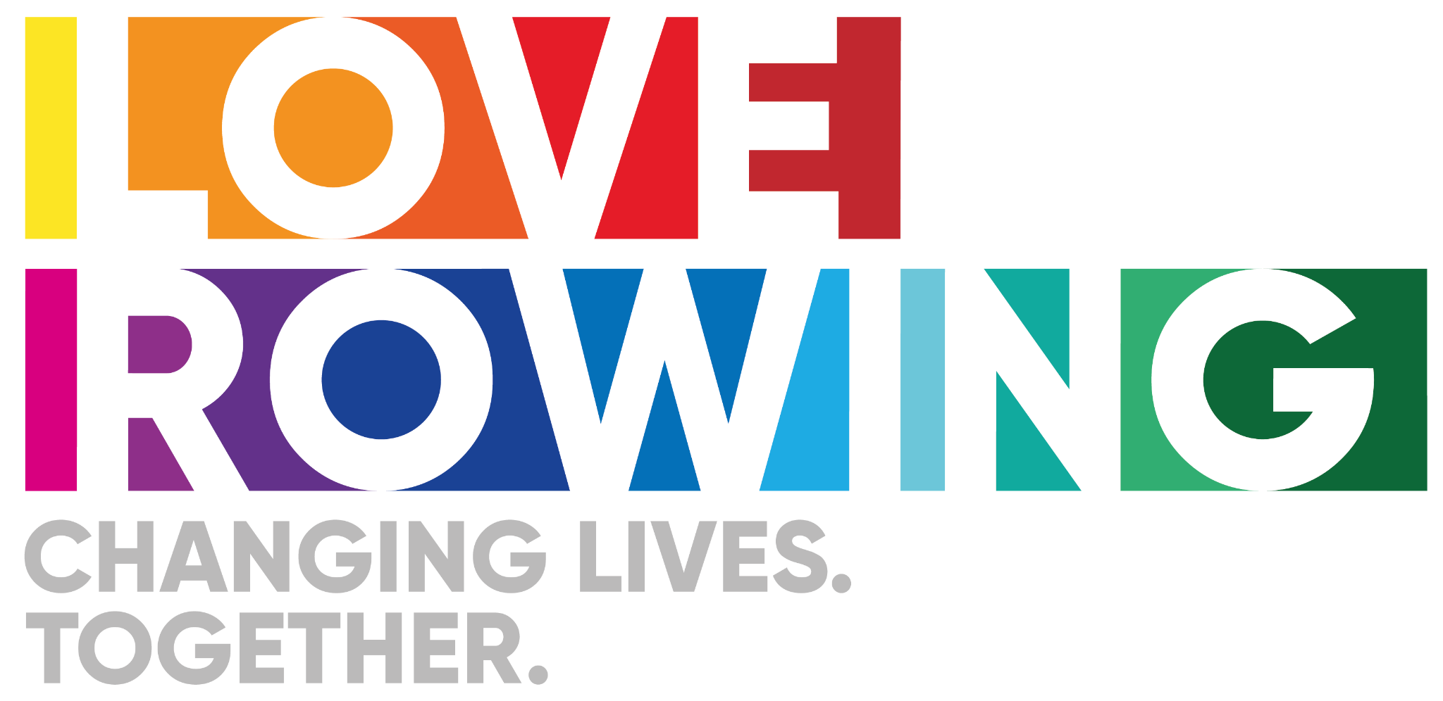
Love Rowing Community Project - Empowering Lives Through Rowing: The Story of Sunderland Rowing Club and the International Community

At Love Rowing, we believe in the transformative power of sport to change lives. Our partnership with Sunderland Rowing Club and the International Community of Sunderland (ICOS) is a testament to this belief, demonstrating how a simple opportunity can create profound physical, mental, and social well-being benefits for individuals who need it most.

The Challenge: Breaking Barriers, Building Bridges
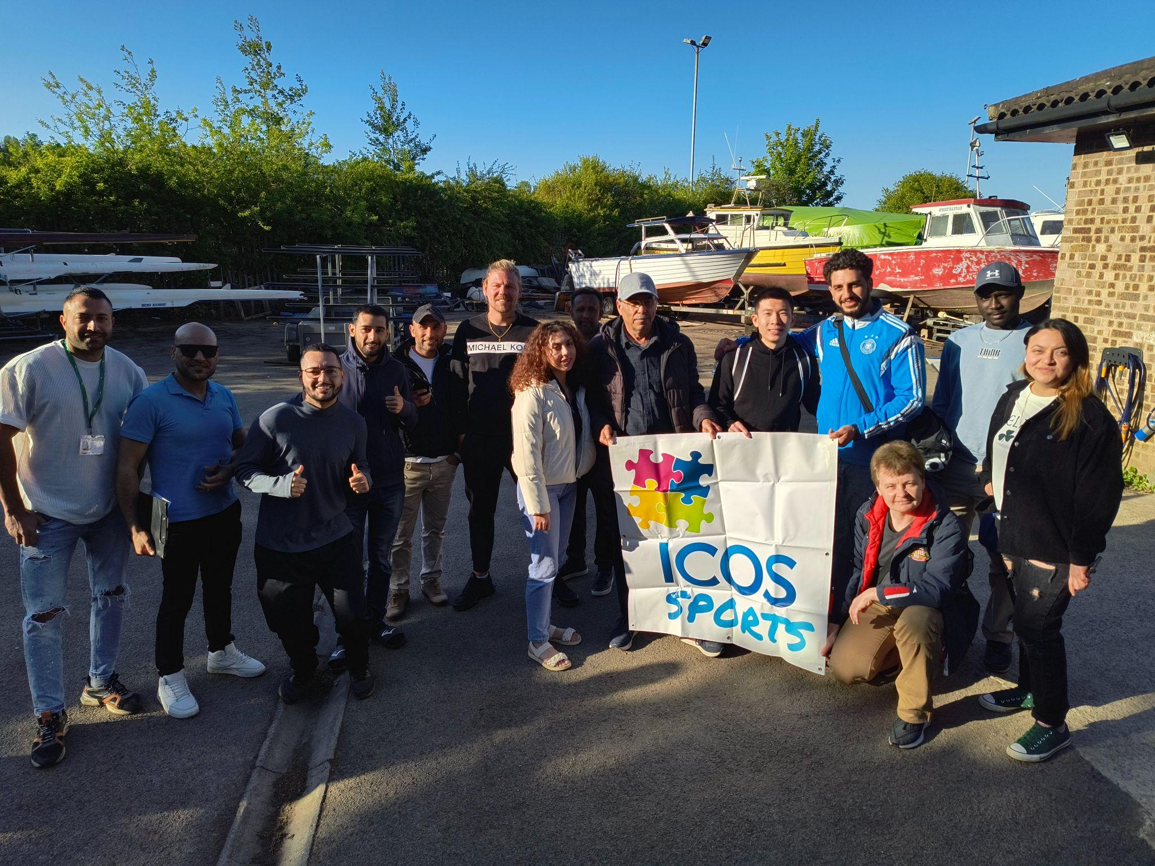
Pre-Covid-19, Sunderland Rowing Club offered a taster session to ICOS, sparking an interest in rowing among a community that had never imagined such an activity. For many, rowing was an unfamiliar concept, a sport they wouldn't have had access to in their homelands. Yet, they intuitively recognized its potential for physical and mental well-being.

Sunderland Rowing Club, a welcoming community hub, faced its own challenges. To truly widen access and improve facilities, financial support was crucial.

In January 2024, both organizations sought Love Rowing's help through our Open Grant Round. While we couldn't support their initial applications, we saw the immense potential in their shared vision. With the generous support of a dedicated donor, we facilitated a new, community-based project in the summer of 2024, engaging refugees and ethnically diverse communities in Sunderland through rowing.

The Project: A Journey of Discovery and Growth

This project specifically targeted ethnically diverse communities, including refugees, asylum seekers, and Eastern Europeans. Our goal was ambitious: to enable 24 individuals to learn and participate in rowing. ICOS, with its deep roots in the local area since 2009, was instrumental in reaching potential participants, ensuring they understood the project's benefits, and helping them overcome barriers to participation.

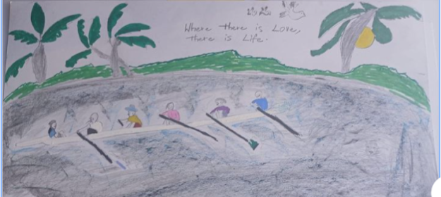
Over ten sessions in the summer of 2024, a diverse group experienced the joy of rowing. While attendance varied, a core cohort of five individuals consistently participated and showed remarkable progress. The impact was tangible, even inspiring a participant to create an image for a mural celebrating the city's heritage. Though the program paused for winter, and some participants moved on due to life circumstances, the seeds of change had been sown.

A New Chapter: Renewed Hope and Lasting Connections

In April 2025, with continued donor support, the project restarted. Love Rowing intensified its efforts to engage the community, not just to open the boathouse doors, but to inspire a small cohort to become regular participants at Sunderland Rowing Club and even begin competing.
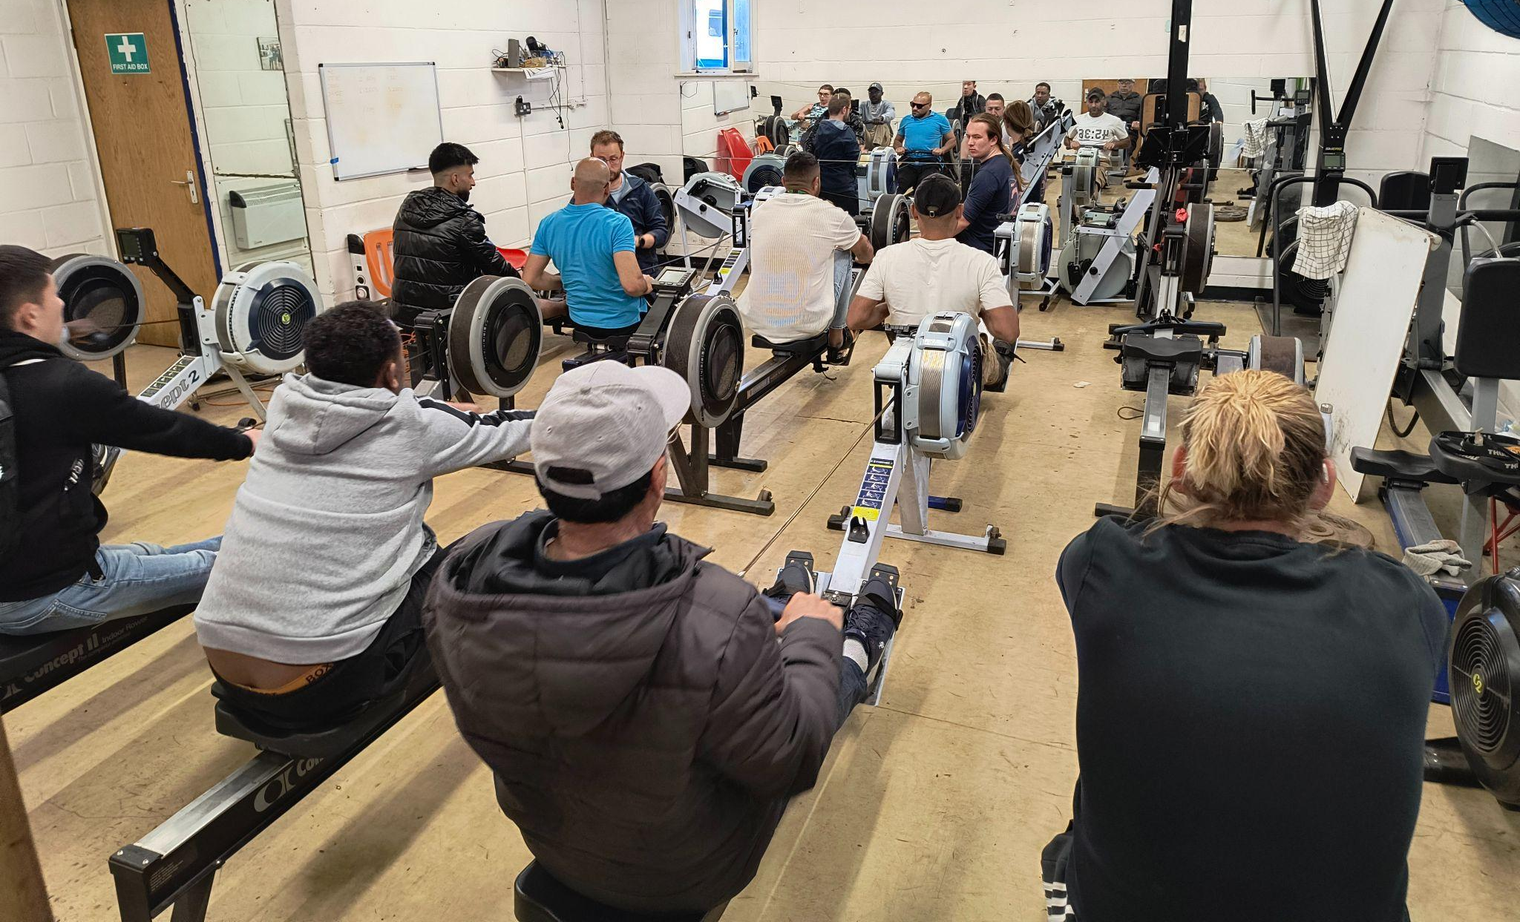
Weekly sessions throughout spring and summer have seen between 3 and 17 participants 45 from various countries and backgrounds, all united by the water.

Chris Webb, Head Coach of Sunderland Rowing Club, eloquently describes the project's purpose: "Introducing rowing to people who would never have had the opportunity and enriching their lives."

Chris emphasizes the project's positive impact on the club itself, describing it as "getting people involved and enjoying the session, without the high-performance pressure of producing results." He adds, "It isn’t about producing champions for Henley but about supporting people to start and enjoy the sport. You can see the difference in people’s confidence from when they arrive to at the end of the session. Everyone is communicating with one another despite the language barriers."

The coaches have also grown, adapting their communication and coaching styles to be inclusive of everyone, regardless of language barriers. The club has learned invaluable lessons in responding to diverse cultural backgrounds, from simple acts like putting up 'No Smoking' signs to support healthy choices and cohesion in the club, to being empathetic and flexible to the challenges faced by a transient population often in low-skilled shift work or education.
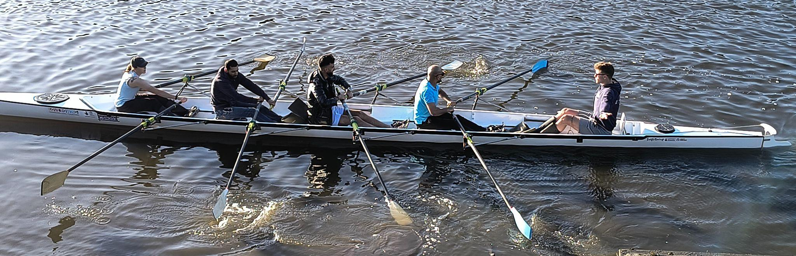
Overcoming Obstacles: The Power of Partnership

The project has highlighted key barriers to participation for the international community:
- Visibility: A lack of visible role models in rowing from similar backgrounds.
- Language: Communication challenges.
- Consistency: Difficulty in maintaining a stable group due to challenging life circumstances.
Despite these hurdles, the project has celebrated remarkable successes. One individual, who enjoyed the rowing but moved to Liverpool, was seamlessly connected with a local club, ensuring their continued participation.

The project's success is deeply rooted in the strong partnership with Daniel from ICOS. With Love Rowing's facilitated funding, Daniel was able to effectively reach out to the community, introduce them to rowing and the club, coordinate participation, and provide crucial transport. The funding also ensured the sessions were free, a critical factor for participants who overwhelmingly stated they wouldn't have participated without ICOS's trusted introduction and the provision of transport.

Voices of Transformation: The Participant Experience
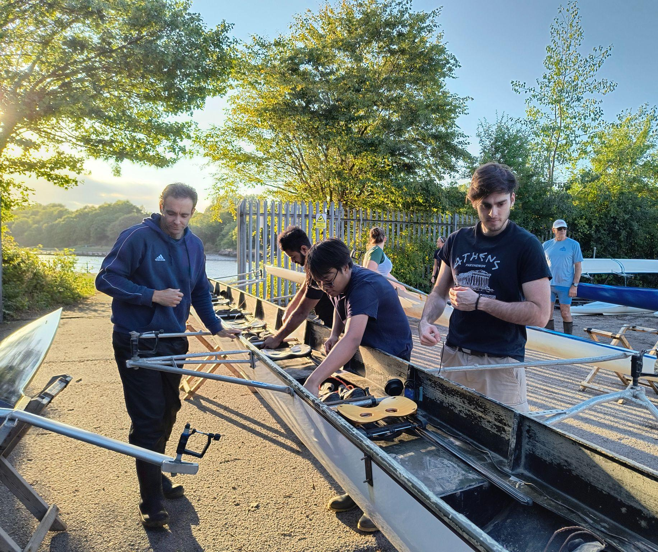
Participant feedback has been overwhelmingly positive, highlighting the profound impact on their physical and mental well-being, as well as fostering vital social connections. We spoke to a few individuals to understand their personal journeys:

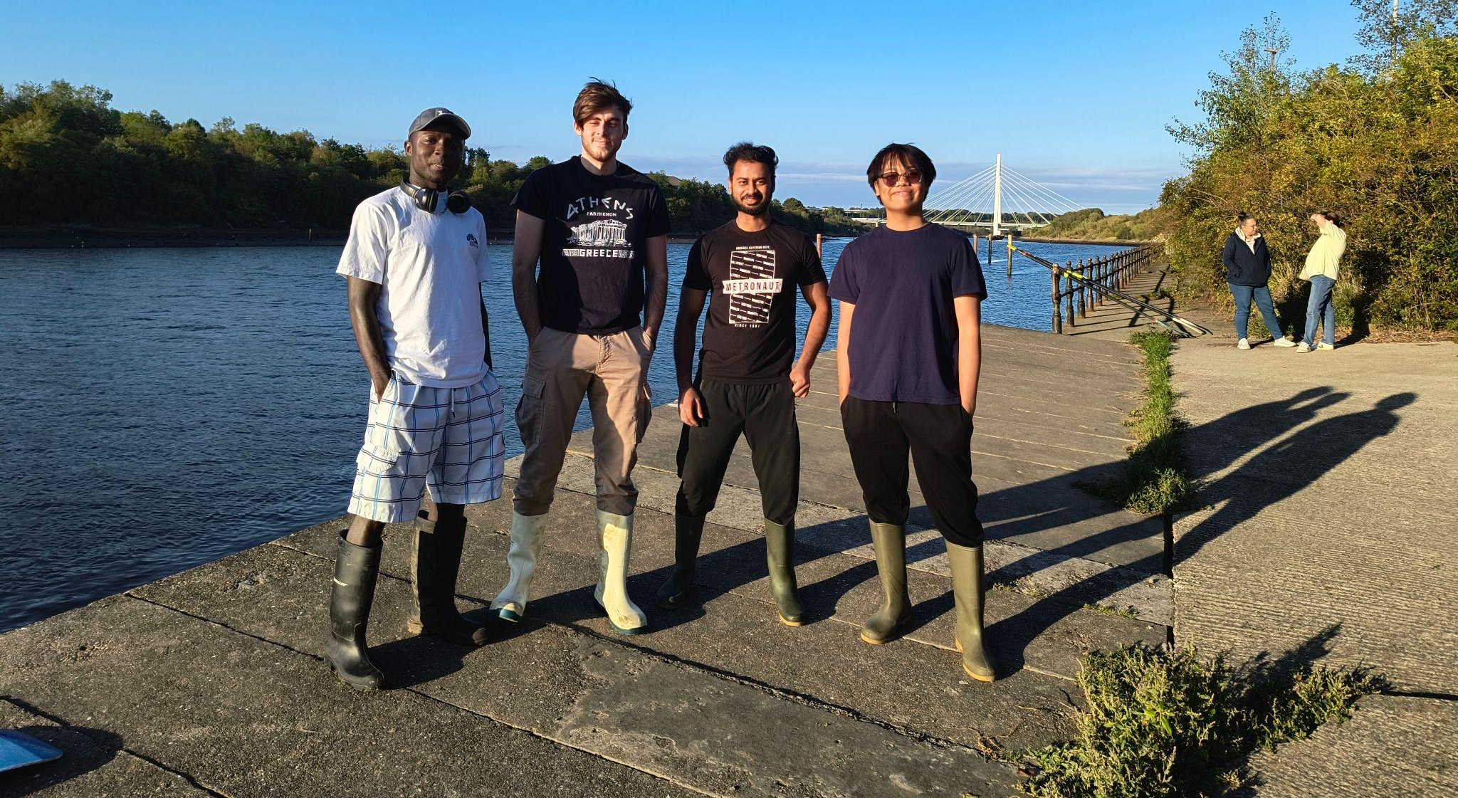
- Participant A (Poland, 7 years in Sunderland): "I am normally an ‘anti-sport’ person, but in ‘mid-life’ I am wanting to prove to myself that I can still do something." The introduction from ICOS made them feel comfortable: "I now know the places, the people, what rowing is and I am comfortable with the activity." She emphasized that without the free sessions and ICOS's support, she would never have tried rowing.
- Overcoming Fear: Participant A, along with many others, bravely confronted and overcame a fear of water. Participant B from Nigeria shared: "Today was my second time on the water rowing, I liked the feel of being able to control the water. I think what have I been afraid of all my life? It has opened my eyes to maybe trying other activities that I have been scared of. Thank you, you have given me this opportunity and it has helped me overcome my fears.”
- Peace and Patience: Participant C from Malaysia beautifully articulated the mental well-being benefits of rowing in nature: "Feeling at peace and at one with nature. The water calms me down and it is training my patience."
- Confidence and Community: Participant D from India, a regular attendee, spoke of the physical health benefits – "it has helped give me energy and see that I am improving." He also highlighted the boost in confidence from positive coach feedback and learning a technical sport. "Rowing brings people together. When I came into the country I was alone. It helps create a community. It builds confidence.”
- Gratitude: Participant C simply expressed her gratitude: “Thank you for providing me with this great opportunity.”
Your Support Makes a Difference

The stories of Participant A, B, C, and D are just a few examples of the incredible impact the Love Rowing Community Project is having on individuals' lives. These are not just statistics; they are real people finding confidence, overcoming fears, building connections, and experiencing peace through the power of rowing.

We urgently need your support to keep this vital project going. Your donation can help us:
- Continue free sessions: Ensuring accessibility for all, regardless of financial background.
- Provide essential transport: Removing a critical barrier to participation.
- Expand coaching resources: To adapt and cater to diverse needs and language backgrounds.
- Improve facilities: To create an even more welcoming and inclusive environment for everyone.
- Foster lasting connections: Helping participants transition into club membership and sustained engagement.

