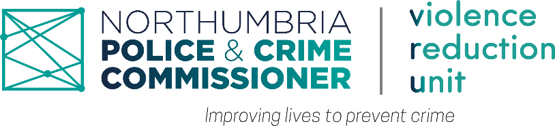
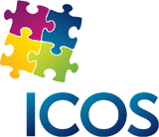

Case Study: Wellbeing Activities for Paula (Pseudonym)
Called Paula, a 40-year-old woman from Kuwait to ask about her experience with the ICOS wellbeing activities. She said she has been a participant of ICOS wellbeing activities for about a year. She learned about these activities from a friend and she was initially drawn to them because of the opportunity to meet and connect with people from various background and exchanging idea enriching experiences.
The client said she looked to gain experience, meet people from different backgrounds and exchange ideas and so far, all these expectations have been men. To her, her favourite part of the ICOS wellbeing activities is the travelling experience and connecting with people. She described ICOS wellbeing activities as really good, supportive and beneficial which she will recommend to people looking for a community to join. Over the period which she has attended, she said The ICOS wellbeing activities has made her happier and less stressed.
The client's experience with ICOS wellbeing activities has been overwhelmingly positive. She has achieved her initial goals of meeting and connecting with new people, and exchanging ideas.

