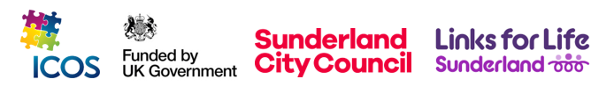

Client A is a single mother with a 13-year-old daughter who attends school in Newcastle. Until recently, they were living in Home Office accommodation in Sunderland while awaiting the outcome of her asylum claim. In June 2025, Client A was granted refugee status.
Following this change of status, Client A immediately faced significant challenges. Because newly-recognised refugees are no longer eligible to remain in Home Office accommodation, she received an eviction notice, leaving her at risk of homelessness. At the same time, she needed urgent support with housing applications, benefit updates, and other administrative requirements to help her and her daughter transition to life as refugees in the UK.
In June 2025, Client A contacted ICOS and her keyworker, Oreoluwa, for support. At their first meeting, she was helped to apply for Universal Credit (UC), enrol in English lessons, and open a bank account. These early steps gave her a foundation for financial independence and integration. Later that month, she also received support with completing her provisional driver’s licence application.
Shortly afterwards, upon receiving the eviction notice, Client A explained that it was important for her to remain close to Newcastle, as her daughter had settled at school there, made friends, and was happy in that environment. To support this, her keyworkers helped her apply for housing through multiple channels: Newcastle Council, Sunderland Council, and Gentoo Housing. Her support worker Oreoluwa, maintained regular contact with both local authorities to monitor progress on her applications.
By July 2025, Client A successfully secured a home in Newcastle, ensuring continuity in her daughter’s education and providing greater stability for the family. With ICOS’s support, she has been able to access benefits, essential services, and suitable housing, important steps toward long-term stability and integration in her new community.

