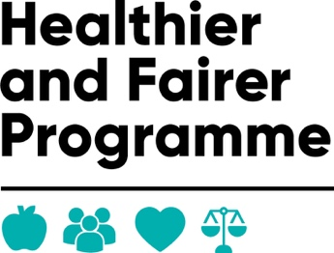

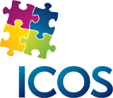

Case Study: Client A
Client A is a 25-year-old man originally from Afghanistan who arrived in the UK seeking asylum. After being granted permission to remain in the country, he was referred to our service for practical support with settling into the local community and accessing essential services. He was allocated a support worker, Bennie to provide one-to-one assistance.
When Client A first engaged with the project, it became clear that he was unfamiliar with many UK systems and processes. He spoke limited English and had no previous experience of managing appointments, online services, or financial administration in the UK. As a result, he required guidance with several important tasks to help him establish independence.
One of the first priorities was ensuring that Client A was registered with a local GP practice so that he could access healthcare when needed. With support, he completed the necessary registration forms and provided the required identification documents. The support worker contacted the GP surgery on his behalf and helped arrange his first appointment. This ensured that he was properly linked into NHS services and able to receive medical care.
Another key area of support was helping Client A to open a bank account. He needed an account in order to receive benefits and manage his finances independently, but he was unsure of the process and anxious about approaching banks. The support worker assisted him with doing the online application, gathering the correct documents, including proof of address and immigration status, and accompanied him to a local branch to complete the application. After several appointments, Client A successfully opened his first UK bank account.
Client A also needed help setting up and using the NHS App. He found digital systems confusing and had limited access to technology. The support worker guided him step-by-step through downloading the app, creating an account, and verifying his identity. They demonstrated how he could use the app to order prescriptions, check appointments, and access health information. This support helped Client A feel more confident using online services and managing his own healthcare.
Throughout the support period, Client A became increasingly independent and better able to navigate everyday tasks. Through his engagement with the project, he was registered with a GP, had an active bank account, and was confidently using the NHS App without assistance.

