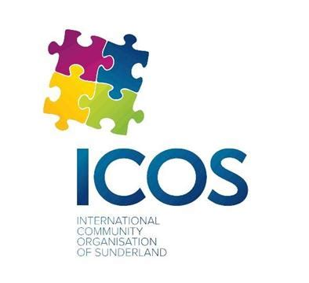

Monitoring Form

ICOS is committed to continuing to further develop our Equality and Diversity Policy and this monitoring document is to ensure we provides equal opportunities to all within the community and to make sure that discrimination does not occur because of race, sex, sexual orientation, gender reassignment, religion of belief, marital or civil partnership status, age or disability.

All information supplied will be treated in confidence and will be stored either on paper records or a computer system in accordance with the General Data Protection Act of 2018 to be used only to monitor the diversity of our activities.

Gender  Sexual Orientation  Gender Identity | Male Female Prefer not to say  Heterosexual Gay Woman Gay Woman Bi Sexual  Prefer not to say  Transsexual Transgender Intersex  Prefer not to say  (If you identify as transsexual, transgender (in that you have effected a permanent change of gender identity) or as intersex which group do you identify with?)
Age Profile | under 16 16 – 24 25–34 35-44 55-64 65 +
2. Marital Status | Married  Divorced | Single  Widowed |  |  | Separated  Other:
3. Ethnic Origin | White British  Black/Black British  Black Other  Asian Bangladeshi  Arab |  | White Irish  Black African  Asian British  Asian Other  Chinese  Other: |  | White Other  Black Caribbean  Asian Indian  Asian Pakistani  Mixed
4. Disability | Do you consider yourself to be disabled under the Equality Act 2010? In the Equality Act 2010, a person has a disability if:  They have a physical or mental impairment.  The impairment has a substantial and long-term adverse effect on their ability to perform normal day-to-day activities.  For the purposes of the Act, these words have the following meanings:  'Substantial' means more than minor or trivial.  'Long-term' means that the effect of the impairment has lasted or is likely to last for at least twelve months (there are special rules covering recurring or fluctuating conditions).  'Normal day-to-day activities' include everyday things like eating, washing, walking and going shopping. |  |  |  |  | Yes  No  Prefer not to say
 | If yes, what is the nature of your disability? (optional)

Working Status  Which of the following best describes your current working status.  If you are in paid work is your employment status | Volunteer Work Paid Work In Education Homemaker  Currently not working Retired  Full Time Part Time Job Share Zero Hours Contract

International Community of Sunderland, Arrow Business Centre,14 Foyle Street,
Sunderland, Tyne and Wear
SR1 1LE

Project Funded by:
